KNOW YOUR CUSTOMER (KYC) APPLICATION FORM


(To be also used for Online Account Opening with AI)

INDIVIDUAL
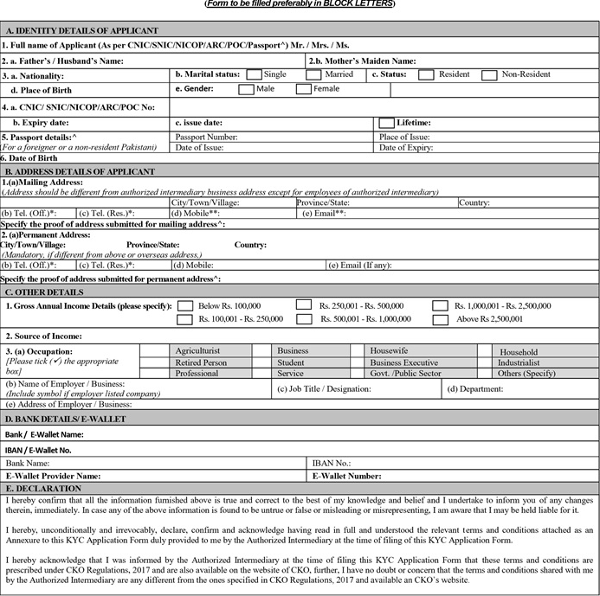
_______________________
Signature of the Applicant Date: __________________ (dd/mm/yyyy) Signature of the Applicant as per CNIC/SNIC/NICOP/ARC/POC/Passport
No^
(Only applicable if Applicant signature is different)
FOR OFFICE USE ONLY
I hereby confirm and acknowledge having provided in full the relevant terms and conditions attached as an Annexure to this KYC Application Form to the Customer at the time of filing of this KYC Application Form.

I hereby confirm that I have informed the Customer at the time of filing this KYC Application Form regarding the availability of these terms and conditions in CKO Regulations, 2017 and on the website of CKO, I further confirm and acknowledge that I have no doubt or concern that the terms and conditions shared with Customer by me are not updated website.

_________________________________ _________________________ ____________________________________
Authorized Signatory Date Seal/Stamp of the Authorized Intermediary
* Optional
** For NICOP/ARC/POC/Passport, Email is mandatory and Mobile Number is Optional. Whereas for CNIC/SNIC, Mobile Number is Mandatory and Email is Optional, however, in case of online account opening, both mobile number and email address are mandatory for resident individual Pakistani customers. In case of SNIC where country of stay is not Pakistan, email will be mandatory.
*** IBAN / E-Wallet Number shall be mandatory for all Customers except for those who have provided an undertaking for exclusion from IBAN requirement due to any exception available under applicable laws, rules, regulations etc or where permitted by CKO for reasons to be recorded.ANNEXURE IIIA TERMS AND CONDITIONS FORMING MANDATORY PART OF KYC APPLICATION FORM FOR INDIVIDUAL AND KYC APPLICATION FORM FOR CORPORATES AS PRESCRIBED UNDER ANNEXURE II AND ANNEXURE III OF THESE REGULATIONS

Terms & Conditions of the KYC Application Form:

1. All terms herein shall, unless expressly stated otherwise, have the same meaning as ascribed to them in the Centralized KYC Organization Regulations.
2. The information provided in KYC application form and/or CRF shall be in addition to and not in derogation of the requirements prescribed under Anti-Money Laundering and Countering Financing of Terrorism Regulations, 2020.
3. All correspondence shall be sent by CKO at the mailing address and/or email address of the Customer, as stated on the KYC Application Form. KYC application form shall be submitted electronically for Online Account Opening of Individual Pakistani Customer by Authorized Intermediary that is a Professional Clearing Member or a Securities Broker.
4. Neither the CKO nor its directors, officers, employees or agents shall be liable for losses, damages, liabilities, costs or expenses suffered or incurred by the Customer as a result of providing its KYC Information to Authorized Intermediaries or the CKO due to any reasons whatsoever including its unauthorized disclosure.
5. The Customer undertakes to indemnify the CKO against any losses, damages, liabilities, costs or expenses suffered or incurred by CKO, including any legal costs and claims by third parties, as a result of any inaccuracy, misrepresentation, misstatement or incorrect details in the information supplied by the Customer or any omission in such information or any other contravention or violation of the Centralized KYC Organization Regulations
6. The Customer agrees that in the event that he does not abide by the timelines prescribed in the Centralized KYC Organization Regulations for submission of information and confirmation to the NCCPL, the NCCPL shall be authorized to take action as prescribed in the Centralized KYC Organization Regulations. The Customer undertakes that it shall hold CKO harmless and that CKO shall not be liable for any losses, damages, liabilities, costs or expenses suffered or incurred by the Customer as a result of such actions.
7. The Customer agrees that CKO may hold, store and process its KYC Information on the KYC Information System and KYC Database in connection with its KYC functions under the Centralized KYC Organization Regulations. The Customer also agrees that CKO may disclose its KYC Information as permitted under the CKO Regulations and such other disclosures as may be reasonably necessary for compliance with any other laws or regulatory requirements.
8. The Customer acknowledges that KYC Information System and KYC Database, including but not limited to all the information contained therein is the legal property of CKO.
9. The Customer agrees that verification against KYC information provided by Customer and Authorized Intermediaries, shall be performed by CKO as per CKO Regulations and such verifications shall include verification of KYC information through linked services such as RAAST, 1-Link, PMD, NADRA, etc. 50
10. The Customer agrees that KYC information provided by Customer at the time of onboarding shall be shared with CDC in pursuance of provisions prescribed by the Securities & Exchange Commission of Pakistan with respect to Central Gateway Portal managed by CDC.
11. The Authorized Intermediaries agree to pay CKO the fees and charges as prescribed by CKO from time to time in respect of its KYC functions.
12. CKO has absolute discretion to amend or supplement any of the terms and conditions at any time and will endeavor to give prior notice of fifteen days wherever feasible for such changes.
13. The Customer agrees and affirms that it shall be bound by and acts in accordance with the provisions of the Centralized KYC Organization Regulations.
14. These terms and conditions shall be governed by the laws of Pakistan. * The terms and conditions will be part of the Online Account Form for Individual Pakistani Customers.

_________________________ _____________________________
Clients Signature Authorized Signatory

EClear Services Limited EClear Services Limited Shaffi Securities (Pvt) Limited
CDCHouse, 99 – B, Block – B, Mezzanine Floor, South Tower, Room No.201, 2ND Floor, LSE Plaza,
S.M.C.H.S., Main Shahra-e-Faisal, LSE Plaza, 19–Khayaban-e-Aiwan 19–Khayaban-e-Aiwan-e-Iqbal,
Karachi. - 74400 -e-Iqbal, Lahore. Lahore.
021-111-111-500, 080023275 042-36302771-2 042-36314730
info@eclear.com.pk info@eclear.com.pk shaffisec201@hotmail.com

